**11.c) Create a VM instance using ansible**

Step 1 : Create Service account with role as project owner and generate json key for that account.

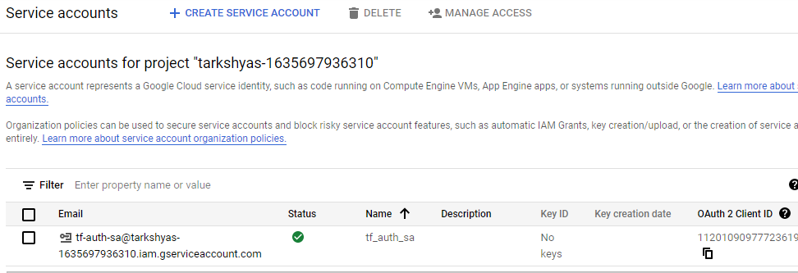

Step 2 : Open the cloud shell terminal and service account key and .yml file

Code containing in the yml file is attatched with this document.

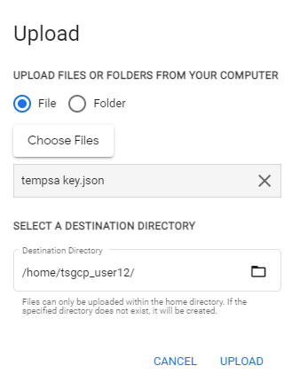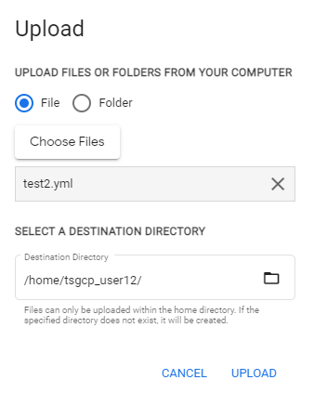

Step 3 : Install ansible version and other google-auth requests in cloud shell using the following codes

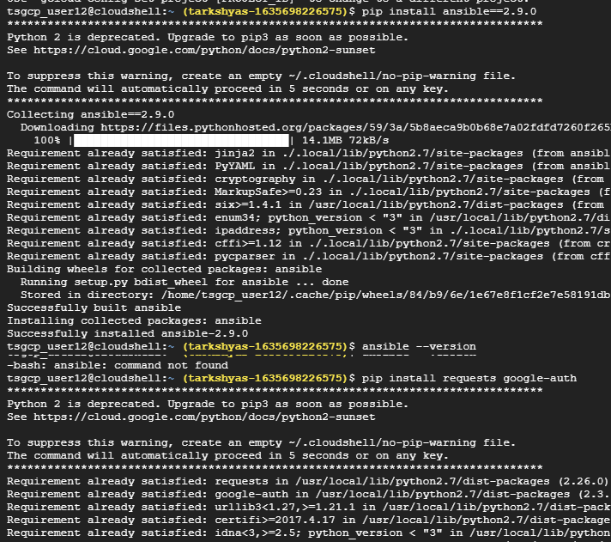

Step 4 : Run ansible-playbook command for creating VM instance

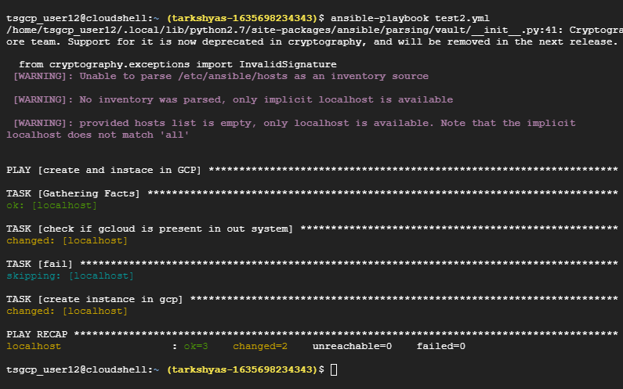

Step 5 : VM instance created successfully

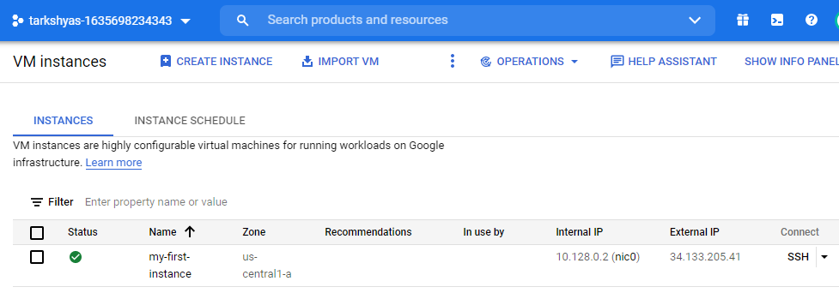

**11.d) Create a SQL instance using ansible**

Step 1 : Create Service account with role as project owner and generate json key for that account.



Step 2 : Open the cloud shell terminal and service account key and .yml file

Code containing in the yml file is attatched with this document.



Step 3 : Install ansible version and other google-auth requests in cloud shell using the following codes. Also install galaxy collections in shell.



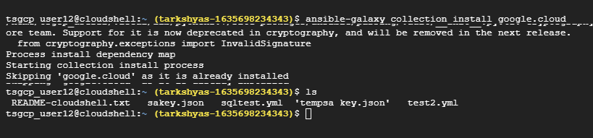

Step 4 : Run ansible-playbook command for creating SQL instance

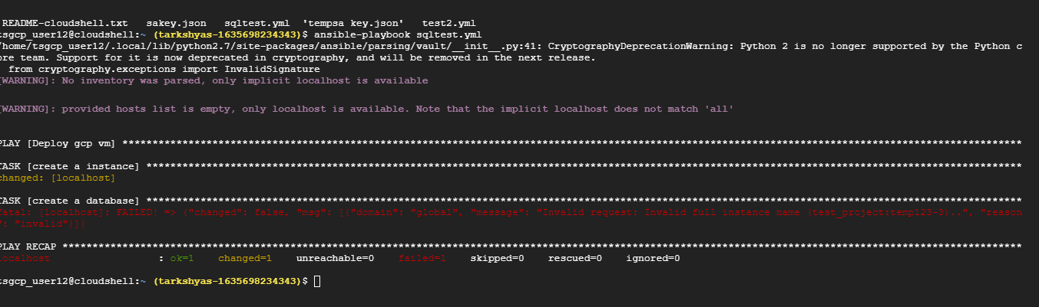

Step 5 : SQL instance with database is reated successfully.

